Compiling CEVis Source Code to Ubuntu OS Environment

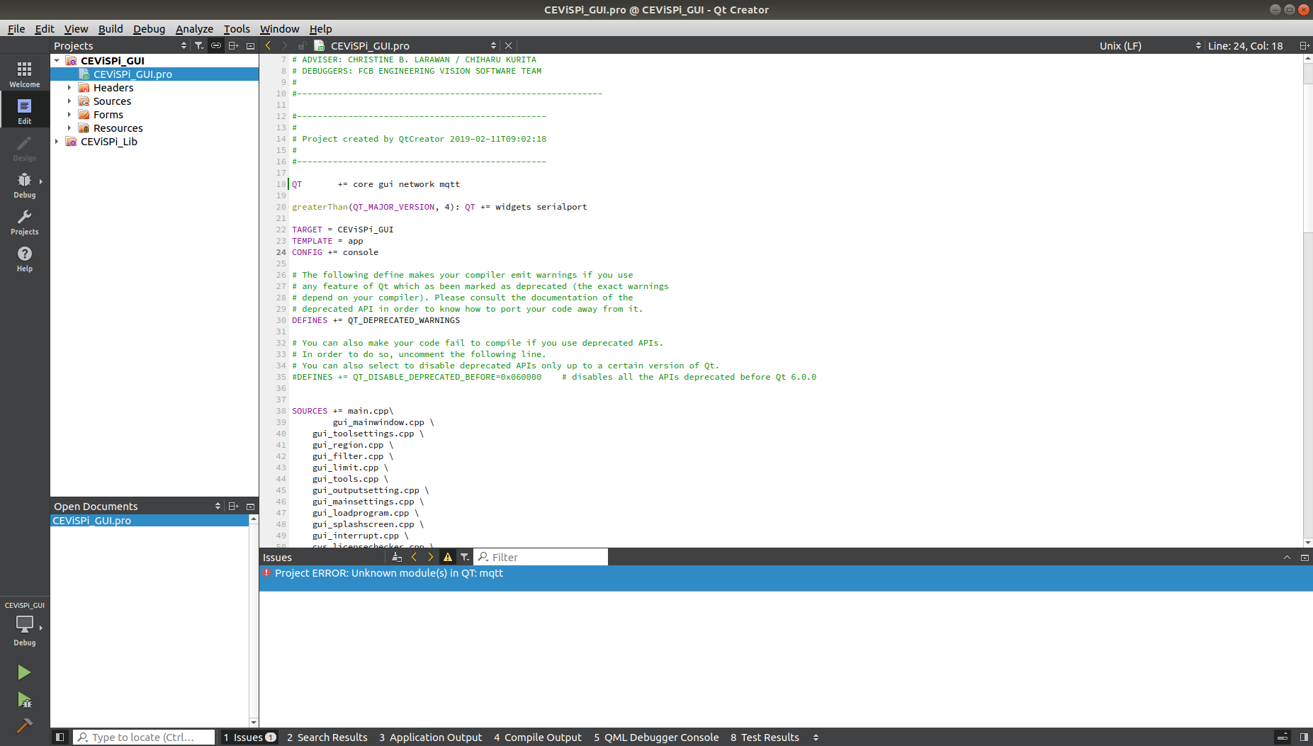
Compile MQTT on Linux

download/clone Qt Submodule from github to Qt Directory:
https://github.com/qt/qtmqtt (git clone https://github.com/qt/qtmqtt.git –branch 5.12)

Note: When cloning Qt Submodule from github, make sure to specify the version same as your qt version to avoid installation error.

Open Terminal on qtmqtt folder and type command inside:
- qmake
- make
- sudo make install

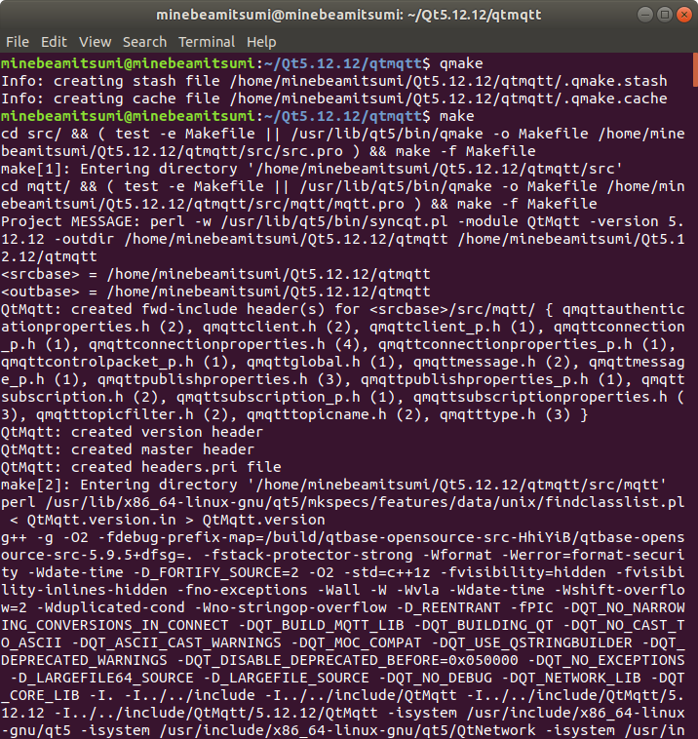

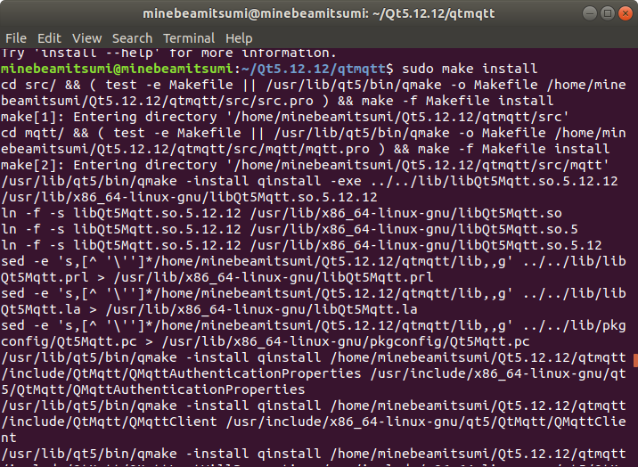

Other way around if it is still popping error “Project ERROR: Unknown module(s) in QT:mqtt”

- Locate the QT_INSTALL_LIBS by typing command to Terminal
- qmake -query QT_INSTALL_LIBS
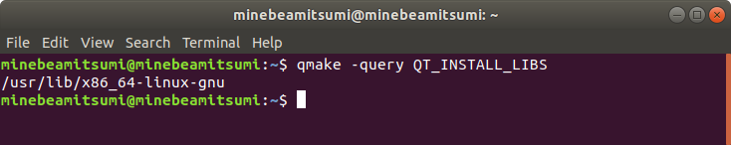

- Clone qmtt repository from https://code.qt.io/cgit/qt/qtmqtt.git/.
- git clone -b <version> git://code.qt.io/qt/qtmqtt.git
- Open Qt Project and Clean build then Run qmake
  - cd qmqtt
  - make
  - sudo make install
- Then build and run Qt Project.

Error build for wiringPi library
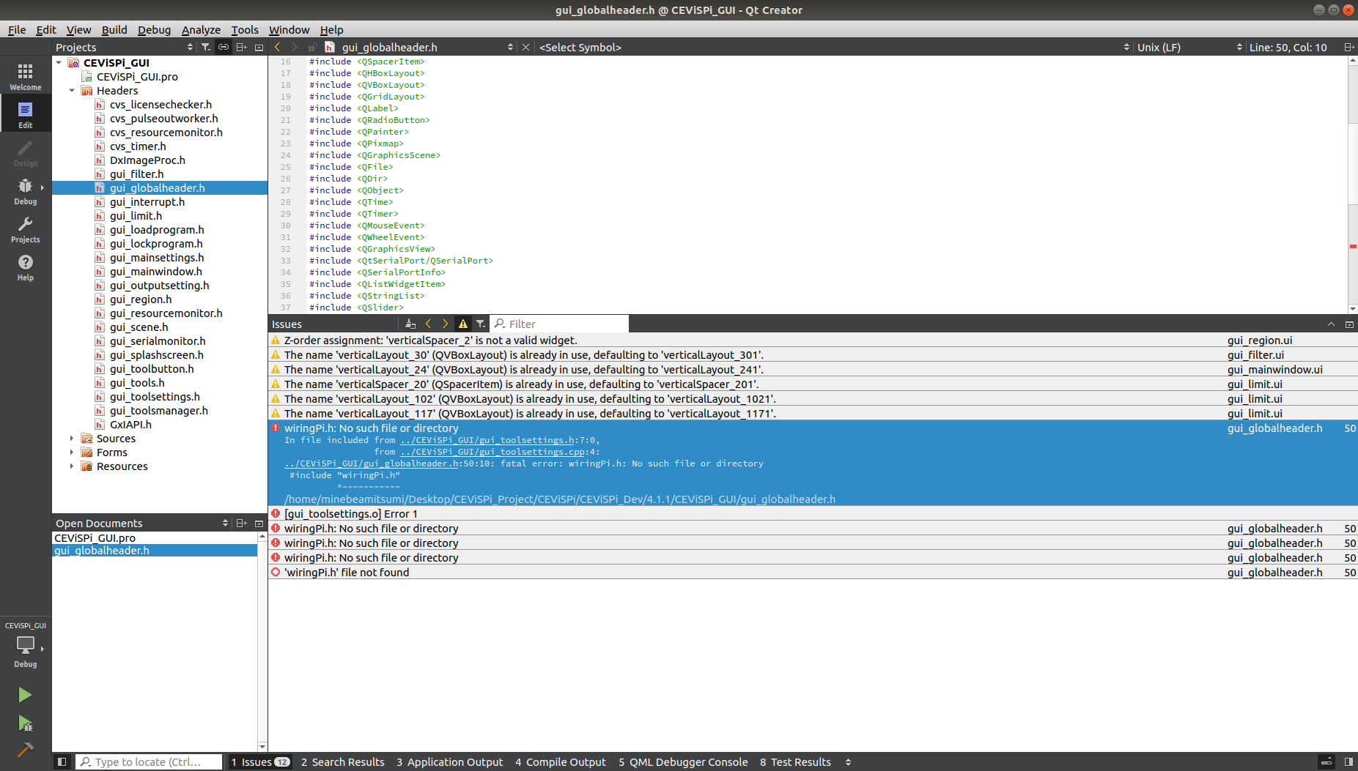
Clone wiringPi repository from https://github.com/WiringPi/WiringPi

- git clone https://github.com/WiringPi/WiringPi.git
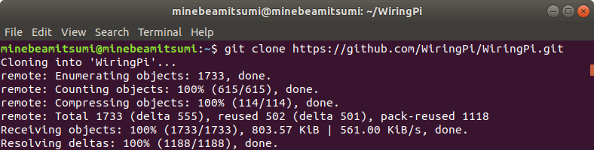
- cd wiringPi
- run ./build
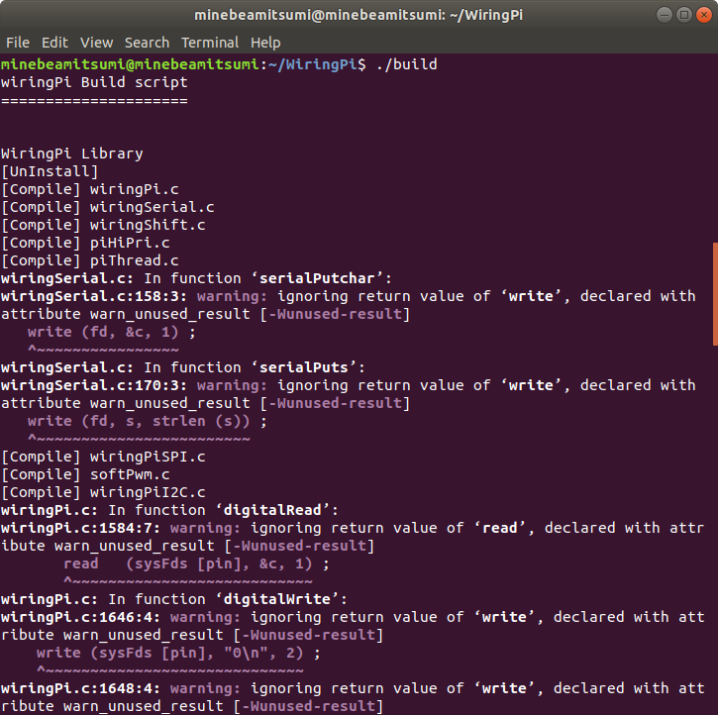

Test if the WiringPi is installed properly by running command on terminal:
- gpio -v
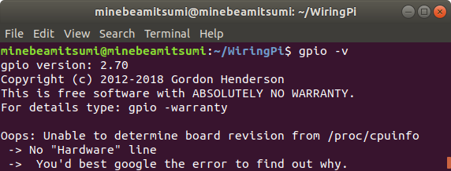

Include default Library to Qt Creator


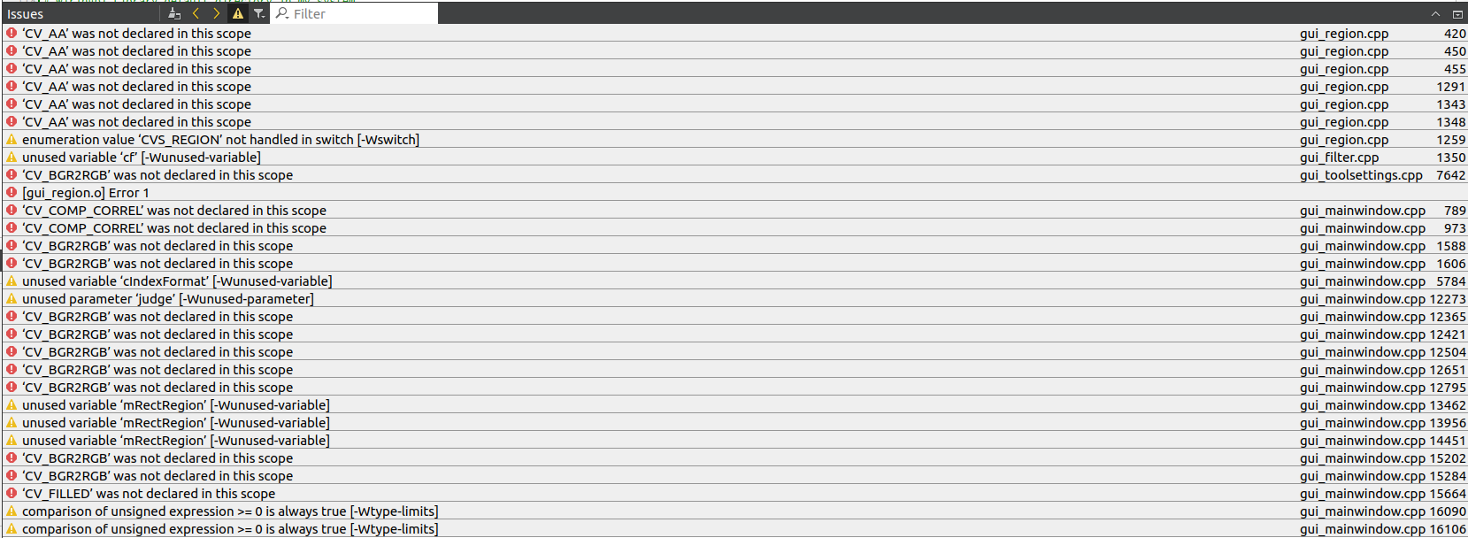
Then build project after wiringPi configuration. Error above shown cause by the opencv version that already installed on my system which is 4.7.0. In that case, I downgraded my opencv version to 3.4.2 which is what required for the system and it stabilizing the build.

Error:

gxiapi library need to be installed on the system from https://www.get-cameras.com/How-to-download-install-and-run-the-Linux-Galaxy-SDK-suitable-for-your-industrial-camera-hardware-in-3-steps
Downloads
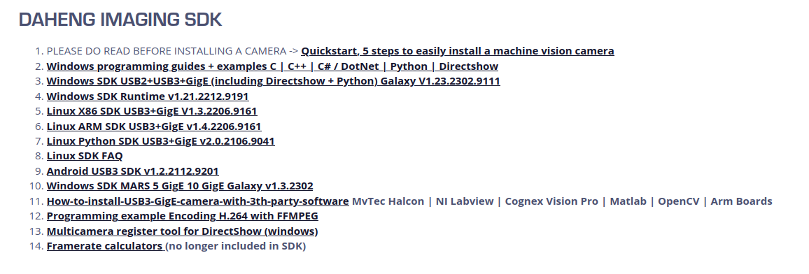
After downloading the SDK. Extract the file and open terminal and type the command:
- ./Galaxy_camera.run
- type Yes and your Password
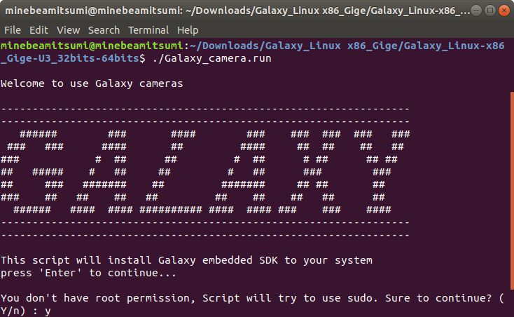

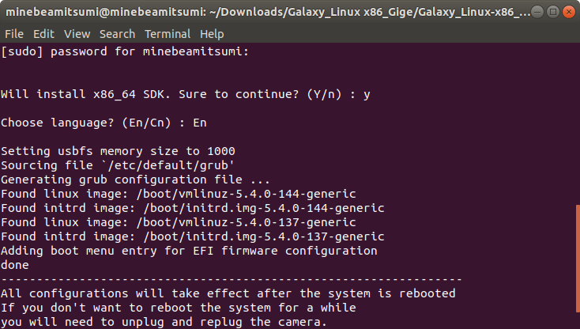

Build error:
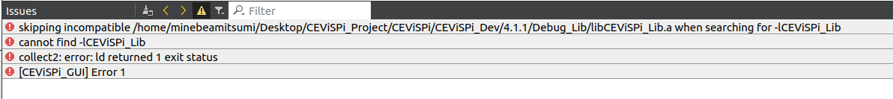
Road block in project migration from raspberryPi device to lattepanda.
Based on what I found, this means that the recent library that running on the CEViSPi are compiled from a ARM-based architecture and it is not compatible with the architecture that targeted to migrate into.
To resolve this, it is nessary/need to compile or rebuild the CEViSPi_Lib using x86_64/AMD64 architecture for the building process in order to run the existing CEViSPi System to our lattepanda which is Linux distro.

